**Tugas3**

**(Membuat Dengan Bootstrap)**



**Disusun Oleh :**

Arief Nauvan Ramadha

Junior Web Developer A

**PELATIHAN VSGA**

**JUNIOR WEB DEVELOPER**

**DIGITAL TALENT SCHOLARSHIP**

**2021**

**Tugas 1**

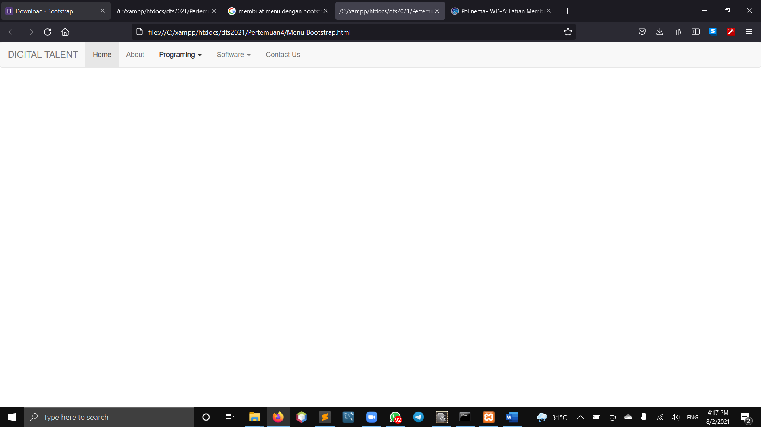

|  |
| --- |
| <!DOCTYPE html>  <html>  <head>  <meta charset="utf-8">  <title></title>  <link rel="stylesheet" type="text/css" href="https://stackpath.bootstrapcdn.com/bootstrap/3.4.1/css/bootstrap.min.css">  <script type="text/javascript" src="https://code.jquery.com/jquery-1.12.4.min.js"></script>  <script type="text/javascript" src="https://stackpath.bootstrapcdn.com/bootstrap/3.4.1/js/bootstrap.min.js"></script>  </head>  <body>  <nav class="navbar navbar-default">  <div class="container-fluid">  <div class="navbar-header">  <button type="button" class="navbar-toggle collapsed" data-toggle="collapse" data-target="#navbar" aria-expanded="false" aria-controls="navbar">  <span class="sr-only">Toggle navigation</span>  <span class="icon-bar"></span>  <span class="icon-bar"></span>  <span class="icon-bar"></span>  </button>  <a class="navbar-brand" href="#">DIGITAL TALENT</a>  </div>  <div id="navbar" class="navbar-collapse collapse">  <ul class="nav navbar-nav">  <li class="active"><a href="#">Home</a></li>  <li><a href="#">About</a></li>  <li class="dropdown">  <a href="#" class="dropdown-toggle" data-toggle="dropdown" role="button" aria-haspopup="true" aria-expanded="false">Programing <span class="caret"></span></a>  <ul class="dropdown-menu">  <li><a href="#">PHP</a></li>  <li><a href="#">ASP</a></li>  <li><a href="#">AJAX</a></li>  <li><a href="#">jQuery</a></li>  <li><a href="#">MySQL</a></li>  <li><a href="#">css</a></li>  <li role="separator" class="divider"></li>  <li class="dropdown-header">Lainnya</li>  <li><a href="#">Laravel</a></li>  <li><a href="#">Vue JS</a></li>  </ul>  <li class="dropdown">  <a href="#" class="dropdown-toggle" data-toggle="dropdown" role="button" aria-haspopup="true" aria-expanded="false">Software <span class="caret"></span></a>  <ul class="dropdown-menu">  </ul>  <li><a href="#">Contact Us</a></li>  </li>  </li>  </ul>  </div>  </div>  </nav>  </body>  </html> |

**Tugas2**

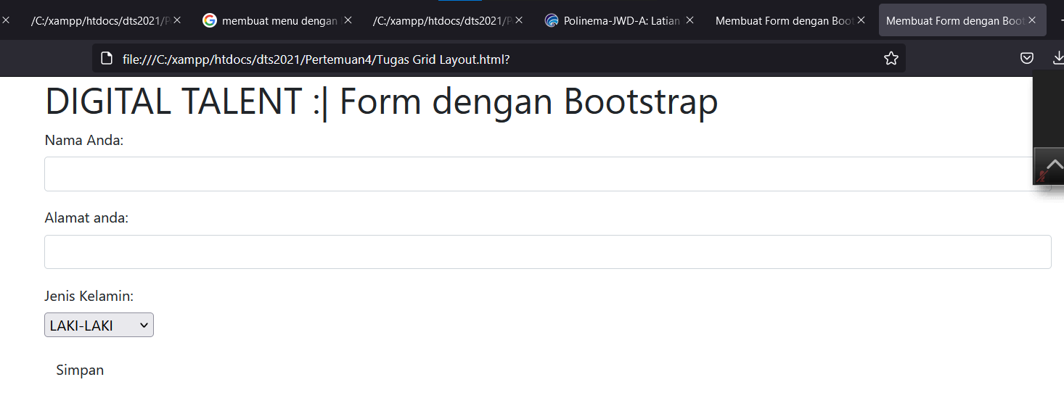

|  |
| --- |
| **<!DOCTYPE html>**  **<html>**  **<head>**  **<title>Membuat Form dengan Bootstrap</title>**  **<link rel="stylesheet" type="text/css" href="css/bootstrap.css">**  **<script type="text/javascript" src="js/jquery.js"></script>**  **<script type="text/javascript" src="js/bootstrap.js"></script>**  **</head>**  **<body>**    **<div class="container">**  **<h1>DIGITAL TALENT :| Form dengan Bootstrap</h1>**  **<form>**  **<div class="form-group">**  **<label for="nama">Nama Anda:</label>**  **<input type="text" class="form-control">**  **</div>**  **<div class="form-group">**  **<label for="alamat">Alamat anda:</label>**  **<input type="text" class="form-control" id="alamat">**  **</div>**  **<div class="form-group">**  **<label for="Jenis Kelamin">**  **Jenis Kelamin:**  **</label>**  **<br>**  **<select>**  **<option>**  **LAKI-LAKI**  **</option>**  **<br>**  **<option>**  **PEREMPUAN**  **</option>**  **</select>**  **</div>**  **<button type="submit" class="btn btn-default" type="color : blue">Simpan</button>**  **</form>**  **</div>**    **</body>**  **</html>** |

**Tugas 3**

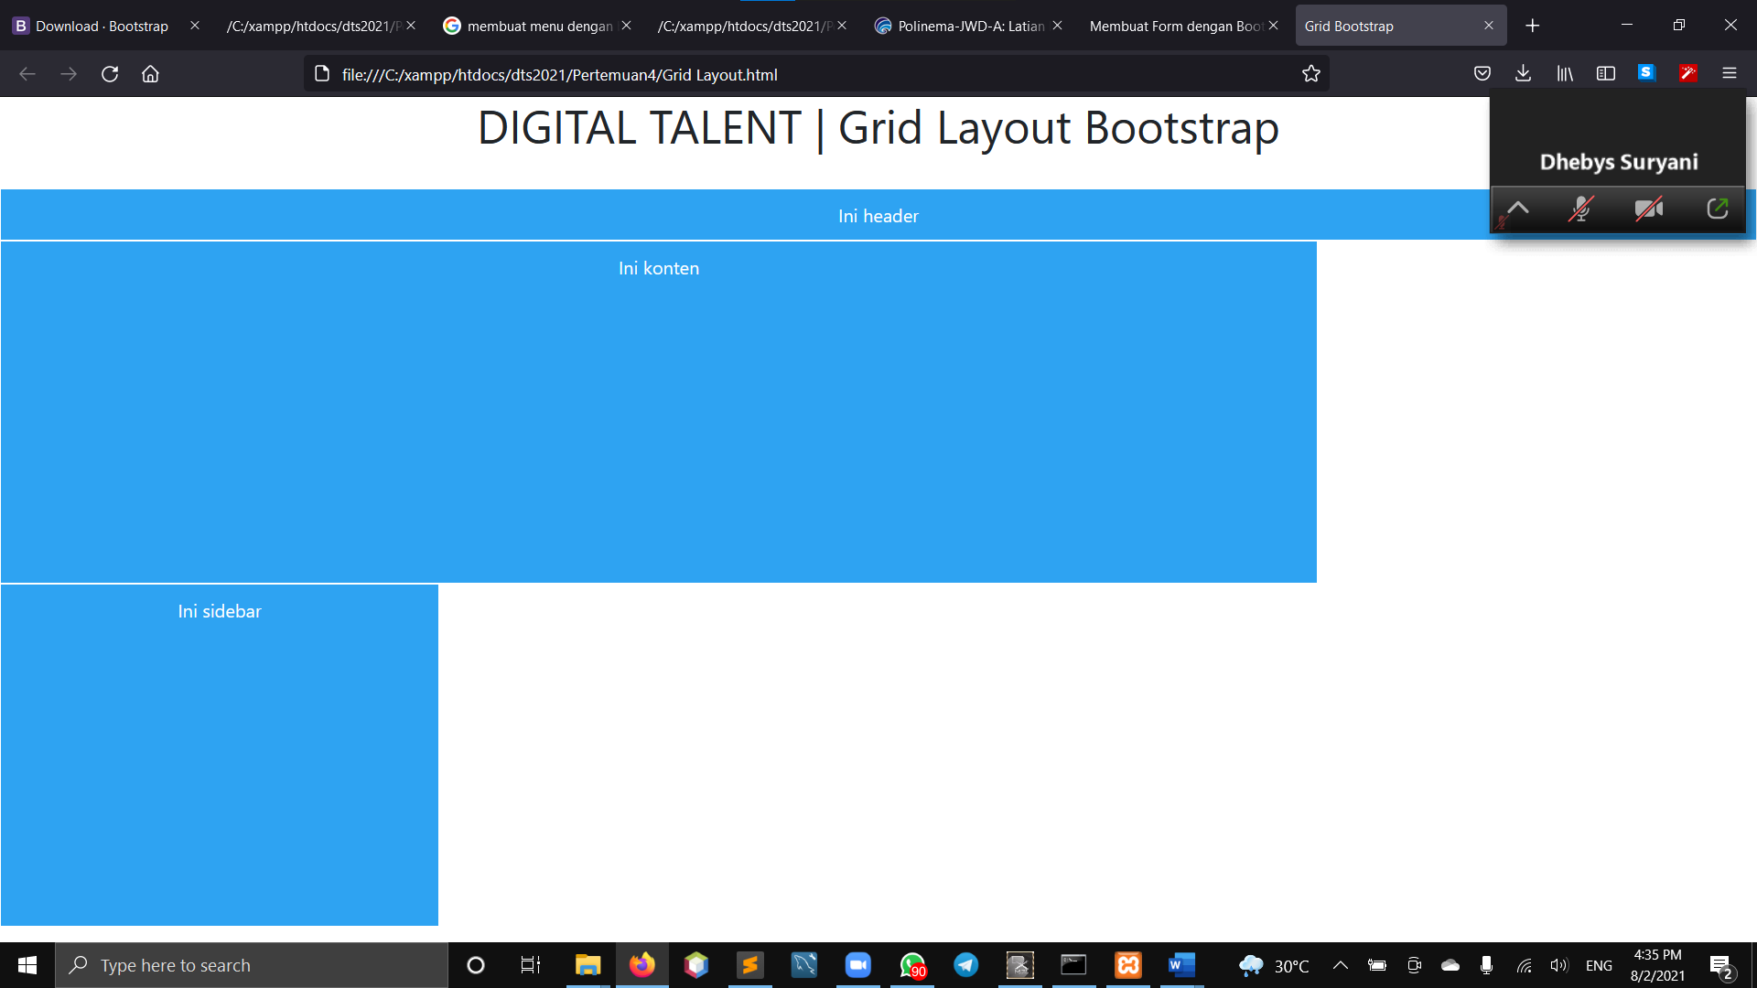

|  |
| --- |
| **<!DOCTYPE html>**  **<html>**  **<head>**  **<title>Grid Bootstrap </title>**  **<link rel="stylesheet" type="text/css" href="css/bootstrap.css">**  **<script type="text/javascript" src="js/jquery.js"></script>**  **<script type="text/javascript" src="js/bootstrap.js"></script>**  **<style type="text/css">**  **div{**  **background: #2ea3f2;**  **text-align: center;**  **border: 1px solid #fff;**  **padding: 10px;**  **color: #fff;**  **}**  **.konten{**  **height: 300px;**  **}**  **.sidebar{**  **height: 300px;**  **}**  **</style>**  **</head>**  **<body>**  **<center><h1>DIGITAL TALENT | Grid Layout Bootstrap</h1></center>**  **<br/>**  **<div class="col-md-12 col-xs-12">Ini header</div>**  **<div class="col-md-9 col-xs-12 konten">Ini konten</div>**  **<div class="col-md-3 col-xs-12 sidebar">Ini sidebar</div>**    **</body>**  **</html>** |